The Mortimer Surgery
Patient Participation Group

Notes of the meeting of the Patient Participation Group held on Wednesday 19th March 2025 commencing 18:15 hours.

Summary of Actions Agreed:
Minute | Action | By whom | By when
01/1 | JB to check email issues with SO | JB/SO | done
03/1 | Contact Willink school | JB | Next meeting
 | Look at NHS App | All | done
04/1 | Invite Lorraine Harper to next meeting | JB | 28/05
05/1 | Website to be kept up to date | JB / PP | ongoing
05/2 | Uneven footpath – raise with partners again | PP | Next meeting
 | Book meeting room for workshop and send out details | JB | done
06/1 | Give EH access to earlier records etc | PP | Next meeting
06/2 | Look at surveys to discuss next time | All | Next meeting
06/3 | NHS App flyers etc. for stall | JB/PP | Next meeting
07/1 | Ask doctors about possible speakers for the proposed topic for public meeting | PP | Next meeting
07/1 | Think about possible speakers | All | Next meeting
07/1 | Check with school about possible speakers and with LH | JB | Next meeting
07/2 | Check availability of hall for public meeting | JB | pending
 | Book hall | JB | pending
08/1 | Book stall at Mortimer Fun Day | JB | done
09/1 | Sort out noticeboard in Surgery lobby | JB | ongoing

Present

John Bagshaw JB (Chair)
Simone Pulleyn SP
Diana Marlow DM
Jean Wates JW
Eddie Holweger EH
John Miller JM
Brenda Neeves BN

Practice Staff
Eva Van de Meuren EVM
Penny Palmer PP

Apologies
Shirley Cullup SC
Maryam Rizwan MR
Mollie Lock ML
Janet Patterson JP

Mentioned not present
Lorraine Harper LH (Social Prescriber)

No. | Discussion Item | Action
01/ | Welcome & Apologies for absence:  JB opened the meeting and welcomed everyone  Apologies for absence were received from SC, MR, JP and ML.  PP reported that due to circumstances none of the senior doctors were available, hence her presence. JB welcomed the input from the Practice Manager on this occasion.  The minutes of the previous meeting had been distributed and were approved. SO had not received them, JB to investigate email issues. Previous action items were completed or ongoing as shown above. | JB
02/ | Declaration of Conflict of Interest:  None were made.
03/ | Matters arising  - JB had obtained a contact name and email for Willink School and sent a request to meet, awaiting response.  - Discussion of the ease of access to and limitations of the NHS App took place. EH reported difficulties and said that he could only access records back to 2020. DM had taken 2 ½ days to get it installed. BN was confused between the NHS App and Patient Access. See later agenda item for more. | JB
04/ | JB update  - The West Berkshire Patient Panel met on 13th attended by representatives of PPGs from West Berkshire surgeries and were joined by Olivia Bailey, the MP for Reading West and Mid Berkshire. She told the group that the Darzi Report had revealed shocking findings on the state of the NHS and public feelings about it. A £26bn increase in budget had been made, the biggest increase since 2010. Areas of focus were GP contracts and the 10 year plan, with shifts from hospital to community , analogue to digital and sickness to prevention as the priorities. The abolition of NHS England was part of this refocus of resources. OB was pressing the case for the re-appraisal of the timing for money for the new Reading hospital hard with the DHSC. WBPP members discussed arrangements in the different surgeries for triage and the push by the BOB ICB for standardisation to the availability for patients between 8am and 6.30pm. The next meeting is on the 22nd May and Lee Dillon, MP for Newbury, will join.  - JB visited the West Berkshire Therapy Centre at Thatcham and brought back some leaflets which he has distributed in the waiting area and displayed on the noticeboard. The WBTC serves patients with conditions such as Motor Neurone Disease, Multiple Sclerosis, Stroke etc. and provides exercise equipment which is power assisted. This can be very helpful in maintaining strength and flexibility for those patients. Older patients without specific conditions are also eligible, if they cannot readily use conventional gym equipment. Ben Frederick is the assessor and Veronica Allsop the manager. A Trust runs the centre and receives grant plus donations e.g. from the Greenham trust. They hope to be able to build a hydrotherapy pool if they can get permissions and funding. JB had hoped to coordinate his visit with LH but could not coincide. An invitation will be sent to her to the next PPG meeting.  - JM reported that Kay Henderson, who works at the WBTC sometimes, is running a new Mortimer Fitness group on Monday mornings 9:30-10:30 and 10:30-11:30 in the Community Centre (opposite the Horse and Groom). | JB
05/ | Surgery Report  - PP reported that the surgery was taking on a new paramedic, Jamie, who will help with the pressure especially for the newer doctors, has started and is doing a course on primary care. The surgery are looking at more use of paramedice under GP supervision, targeting an on-line service between 8am and 6.30pm. Mortimer Surgery will continue the personal triage system unlike some nearby practices which use systems such as Anima which have had mixed responses. Debbie Cowley has left and Lindsay Holmes started as the new administrator. One nurse is on maternity leave but the HCA and Phlebotomist are back. Teething troubles with the new EMIS system which has replaced VISION are now mostly resolved. Lorraine Harper, the Social Prescriber, is very active and appeared on radio Berkshire recently, She has a group that meets at the Bistro once per month.  - JM reported that the footpath past the surgery was very uneven and a trip hazard. PP said this was known and there were difficulties due to tree roots, but she would raise the matter again with the partners. | PP
06/ | NHS App  - PP explained that the NHS App accesses NHS sites as does the Patient Access system which the surgery uses. The 2020 date back to which a patient’s history is shown on the App is a standard default date and the access can be extended to earlier by PP on request, (PP will do this for EH). Patients can download the NHS App and then request to PP to link to the PA for medical history and test results etc. This is the easiest way for patients to get the full utility and we should present it as the way to get set up if asked  - Discussion of a possible manned table display in the surgery waiting area to encourage adoption of the NHS App were led to the idea of combining this with a patient survey as the last full one held by the PPG was some years ago. PPG members should look at the surgery website to see the survey results from last time. JB has researched this and found the full survey (GPAQ-R ) is available to GPs and should be given to patients after a consultation if they want to use it. The Friends and Family test is much simpler, but again is designed to be completed after a consultation so it does not look useful for people waiting to see the doctor. See attached screen shots of both surveys from the surgery website. To be discussed further.  - Dates for an NHS App table display to be suggested by JB. Flyers/posters etc should be available to the surgery from Healthwatch or BOB ICS – check with PP | PP  JB/All  JB/PP
07/ | Public Meeting  - Discussion of possible topics led to the general conclusion that a topic around child and adolescent mental health could be the most helpful to the surgery and of greatest interest to the public, particularly after the very well received TV drama Adolescence. PP will see if the doctors have any thoughts on a speaker and the PPG members will give it some thought too. JB to check with the school as the main topic of the drama was bullying. Also with LH?  - Dates available at St John’s Hall are limited, and Wed 17th September was chosen. DM said that daylight was important to many people in which to arrive. JB attempted to book the 17th but it had gone, booked the 16th and received a call to say that was mistakenly available on the calendar but subject to a regular booking. JB is waiting to hear if the 17th might be made available (sun sets 19:13), otherwise the earliest dates are now 15th Oct (sun sets 18:10)or 22nd Oct (17:55). | PP  All  JB  JB
08/ | Mortimer Fun Day  - On 5th July this event will take place on the Fairground and Mortimer organisations can have a space free. It was agreed for JB to book one, the surgery has a gazebo and can provide a table and a chair. We can run a quiz and have leaflets promoting the NHS App and the PPG, with a prize bottle of wine (or non-alcoholic equivalent) and chocolates. Quiz questions e.g. what can be done with the NHS App, how far back can one see records, when is the next appointment with Dr… (can check live at the end of the day) etc.. | JB
09/ | AOB  - JB checked with PP about using the noticeboard in the lobby, and unauthorised posting of a flyer for bowling which can be removed, JB to add notices. | JB
06/ | Date of next meetings:  The next meetings are April (16th) June (18th) and September tbd dependent on the Public Meeting

Minutes approved on _________________________

Signed _________________________________Chair

Friends and Family Test -

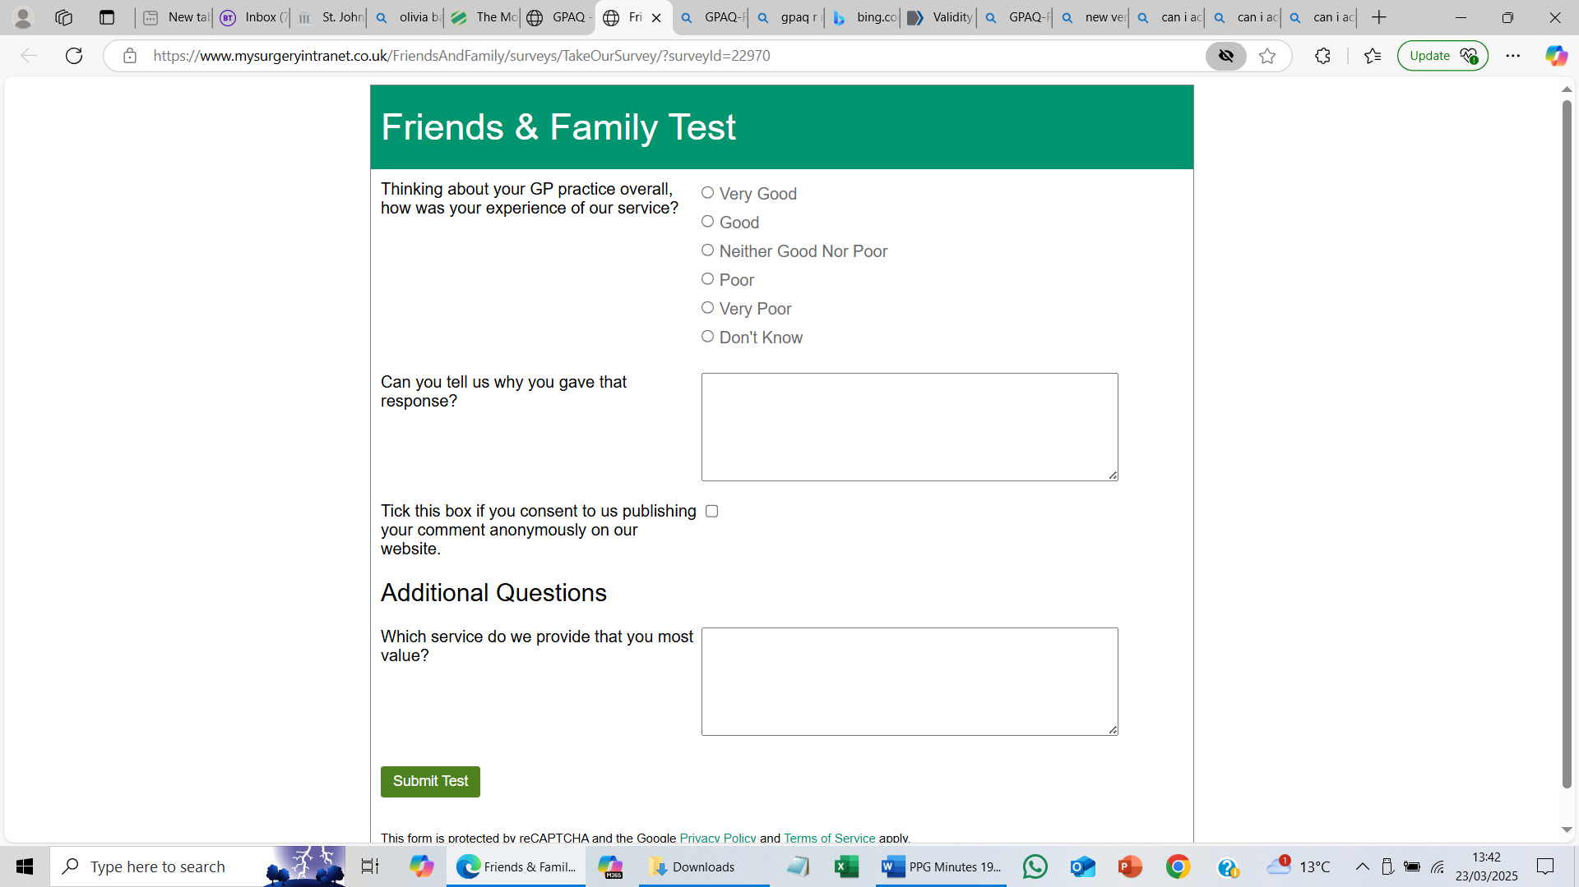

Survey Results

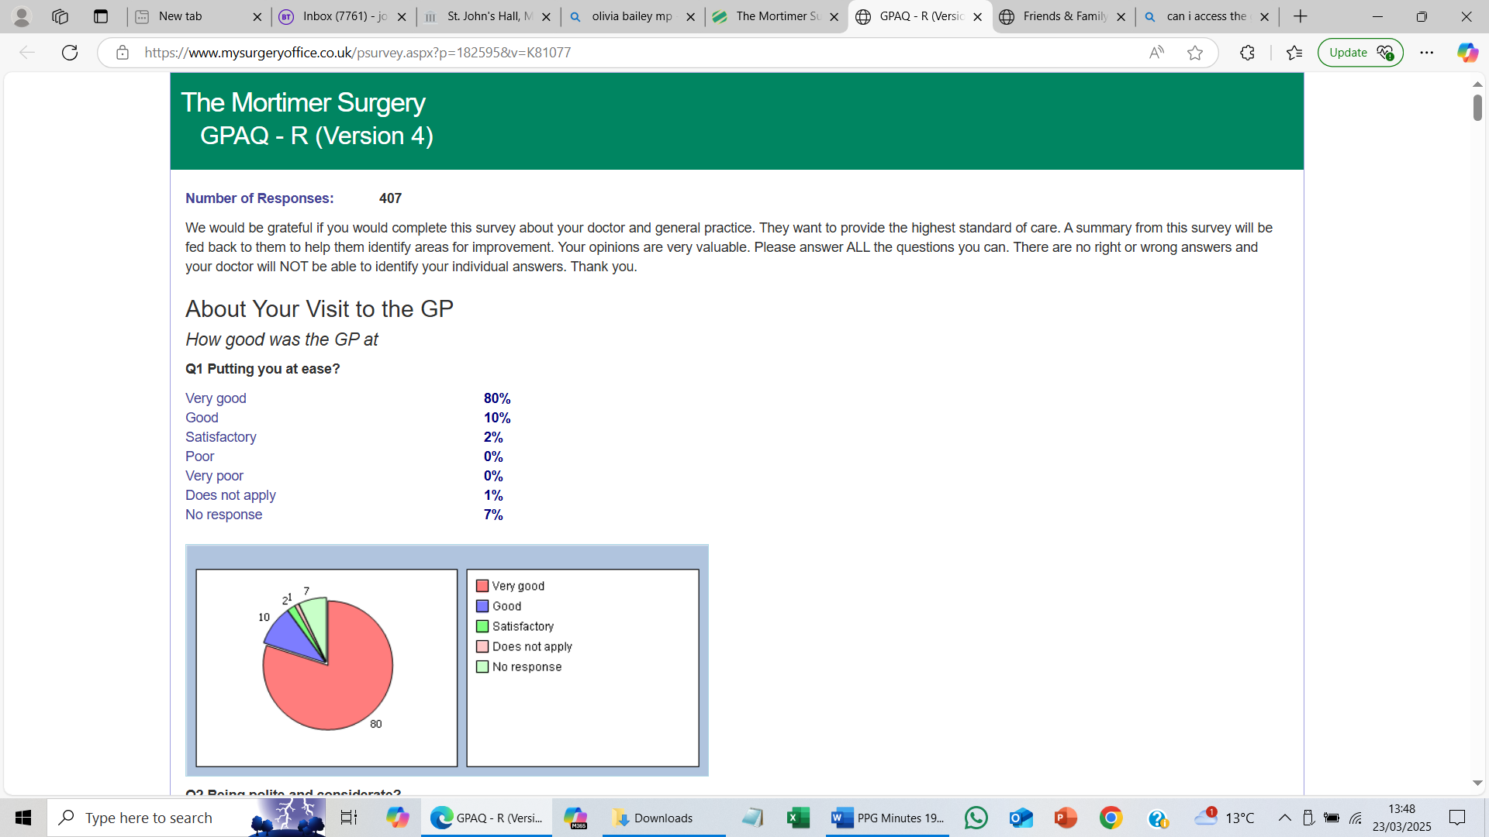

Accessing the GPAQ-R Survey in the UK
The GPAQ-R survey is freely available for individual practices to download and use, but commercial organizations may need a license to access it.
Overview of GPAQ-R
The General Practice Assessment Questionnaire - Revised (GPAQ-R) is a patient experience questionnaire designed for use in general practice in the UK. It was developed to meet the requirements of the General Medical Council (GMC) for revalidation and to assess patient experiences related to various aspects of care, such as access and interpersonal interactions

biomedcentral.com+1

.
Accessing the Survey
- Availability: The GPAQ-R is freely available for individual practices to download and use. However, commercial organizations must obtain a license to access the survey

clarendonmedicalcentre.nhs.uk

.
- Purpose: The survey is intended to help practices gather feedback from patients about their experiences, which can inform improvements in care and service delivery

